
Project Presentation: Personal Portfolio Website
My Name: Amit Kumar Yadav

Project Overview
The Personal Portfolio Website is a modern, single-page responsive platform designed to showcase professional skills, technical projects, and certifications. It serves as a practical implementation of frontend technologies with a focus on clean UI and smooth user interaction.

Core Features:
- Responsive Layout & Adaptive Design: Implemented using a flexible grid-based layout to ensure seamless responsiveness across desktops, laptops, tablets, and mobile devices.
- Project Showcase System: Displays real-world projects with technology tags (HTML, CSS, JS), GitHub links, and expandable views.
- Interactive UI Components: Features integrated hover effects, smooth section transitions, and modal image previews for certifications.
- Professional Branding: Includes a specialized profile summary and professional imagery to establish a clear developer identity.

Website Modules & Navigation
The portfolio is divided into several specialized modules for organized content delivery:

1. Home Module (index)
• Impactful Hero Introduction: The page features a prominent greeting and your name, Amit Kumar Yadav, paired with your professional title as a Frontend Developer to provide immediate role clarity.
• Central Navigation Hub: A clean header menu provides instant access to all critical modules, including About, Skills, Contact, and your Resume.
• Professional Visual Branding: A high-quality professional headshot is integrated into the layout, framed with a stylized blue glow that maintains visual consistency with the site's dark-themed aesthetic.
• Quick-Action Call-to-Actions (CTAs): Direct links like "GOT A PROJECT?" and "MY RESUME" are placed centrally to encourage immediate user engagement and ease of access to your credentials.

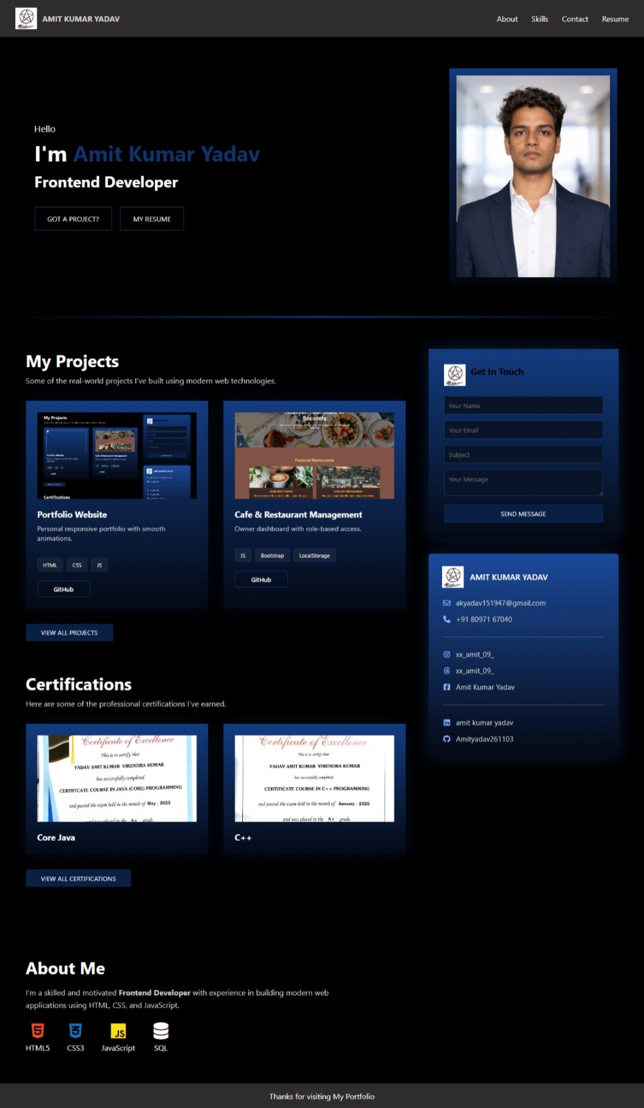

2. About Module (PFAbout)
• Detailed Developer Profile: This section highlights your role as a passionate Frontend Developer, emphasizing your skill in creating efficient, scalable web applications and your transition into software development.
• Core Technical Focus: The module specifies your specialization in crafting responsive, user-friendly interfaces using a strong foundation of HTML, CSS, and JavaScript.
• Visual Skill Representation: To enhance scannability, the page features dedicated sections for "My Skills," showcasing technologies like HTML5, CSS3, React.js, and SQL, alongside a broader "Why work with me?" section that highlights your creative problem-solving abilities.
.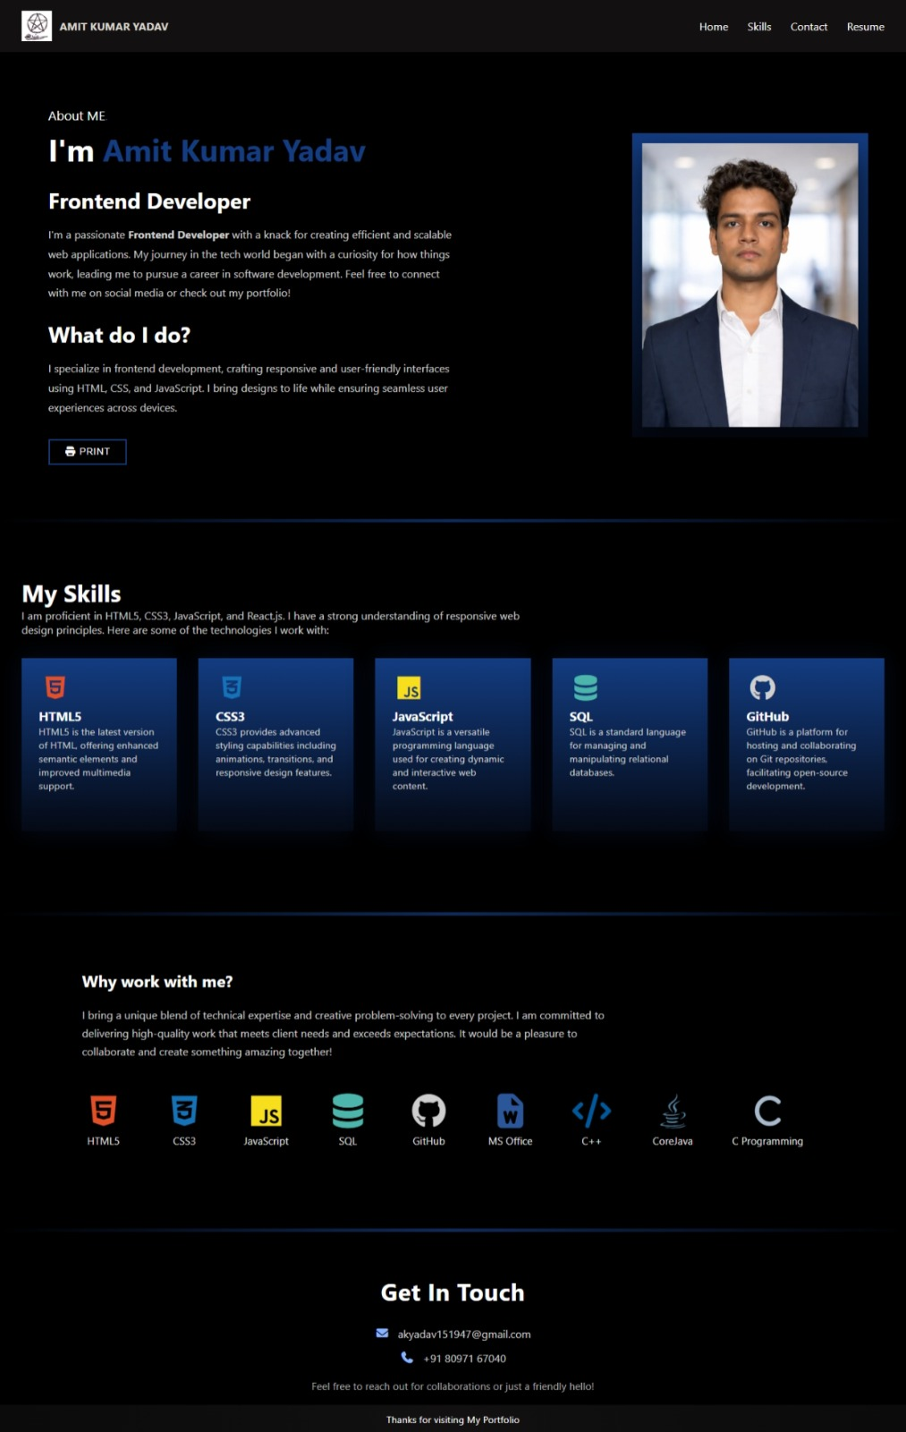

3. Skills Module (PFSkills)
A comprehensive display of technical proficiency categorized into:

- Languages: C Programming, C++, and Core Java.
- Web Development: HTML5, CSS3, and JavaScript (ES6+).
- Databases: SQL and Relational Database Design.
- Tools & Platforms: Git, GitHub, and VS Code.
- Office Automation: MS Word, Excel, and PowerPoint.
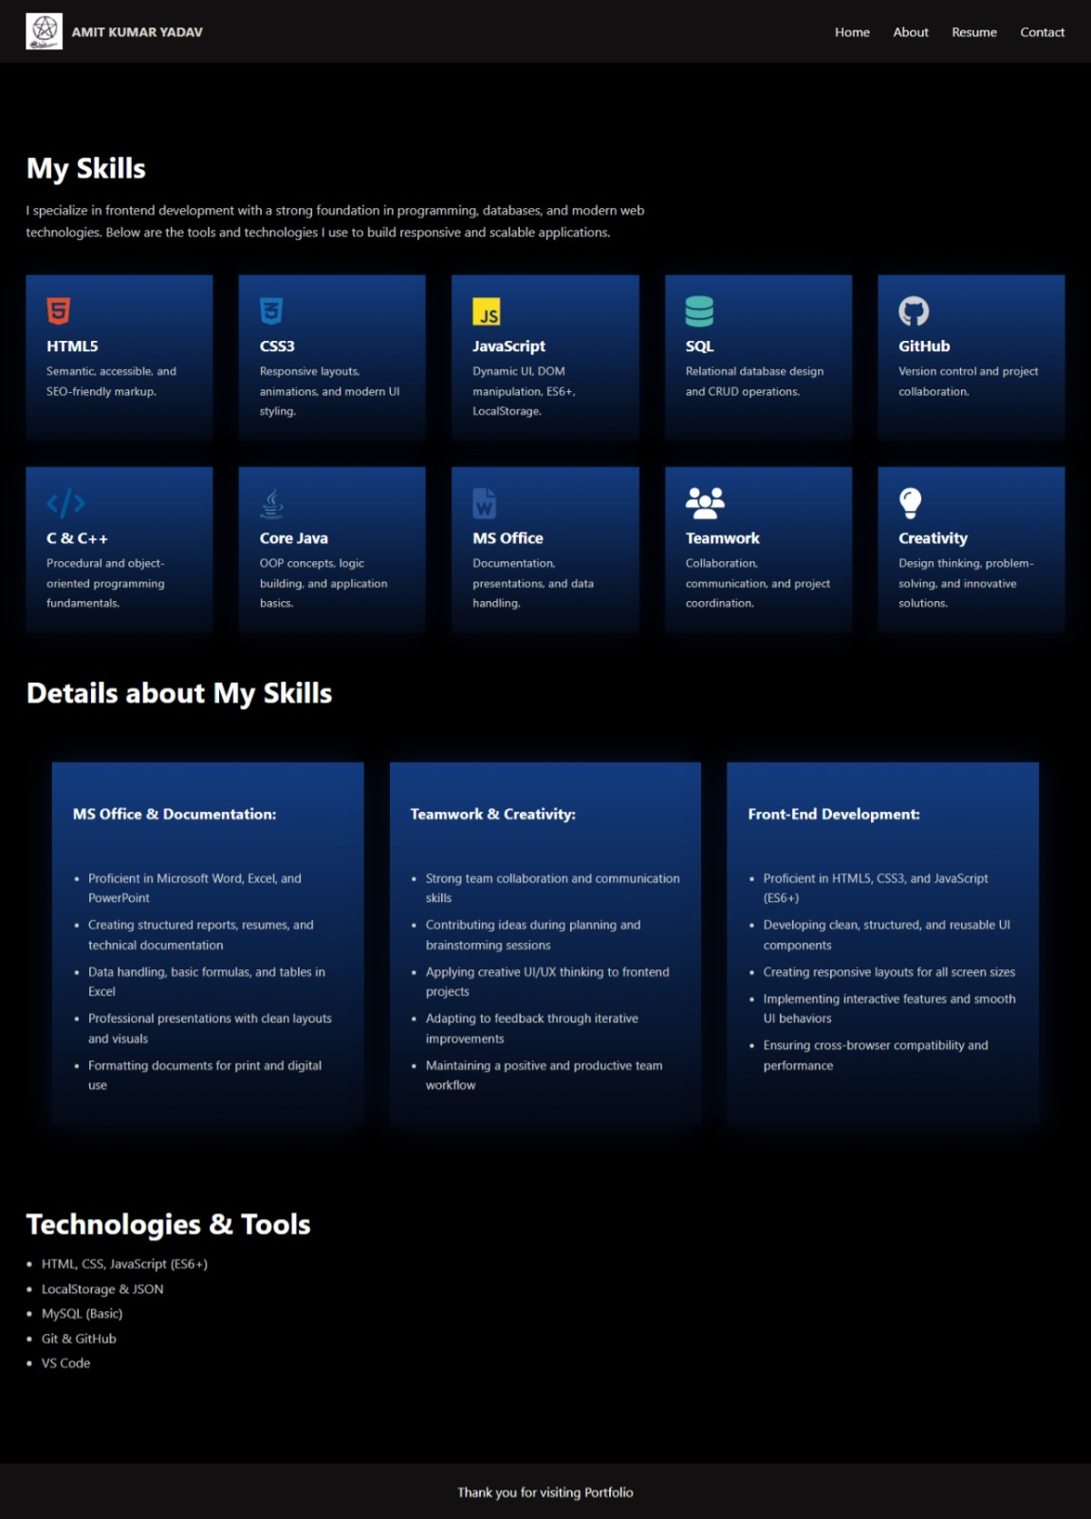

4.Got A Projects Module (PF_Got_A_Project)
Showcases major works including:
- Skill description :. Description of all the technical skills, i have till now. That can help in creating the project including the languages and the database and all the tools that I need to create a project are described in it
- Technologies: A proper description of the tools that I can use to write code and do other things that I have till now did.
- Interactive Engagement Form: The module includes a dedicated "Get In Touch" section featuring a structured contact form that allows visitors to submit their name, email, project subject, and a detailed message directly through the site interface.
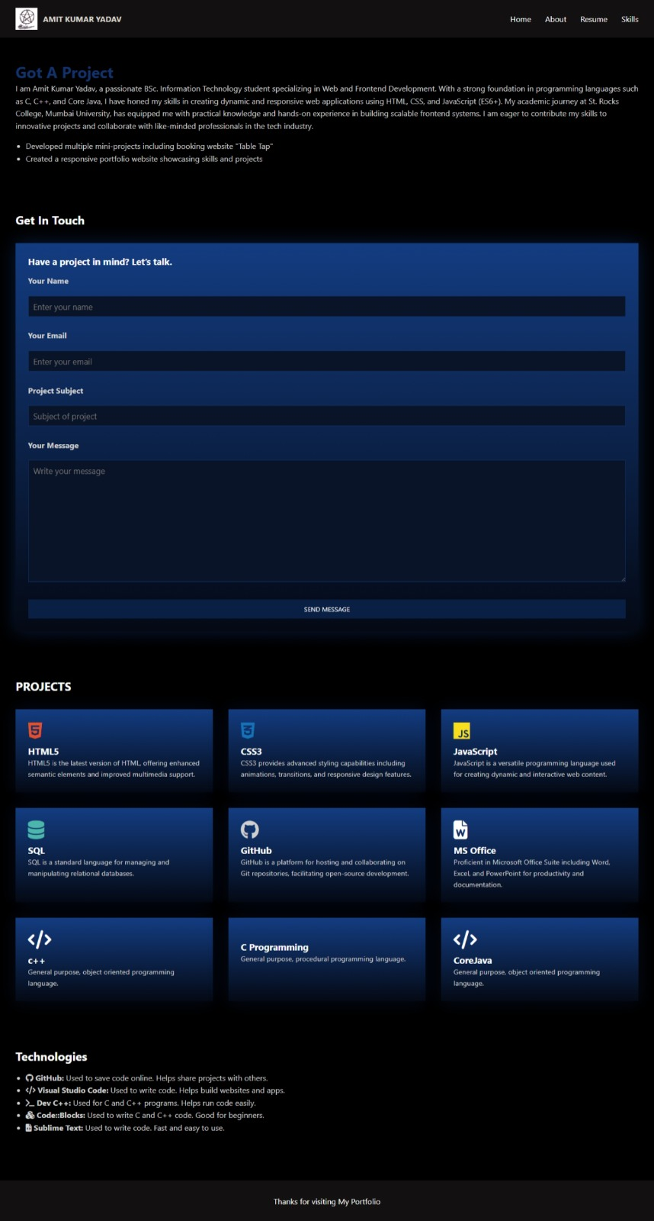

5. Resume (PFResume)
• Professional Summary and Core Competencies: This section provides a concise profile summary highlighting your self-motivated nature and hands-on experience with core technologies such as HTML, CSS, JavaScript, PHP, and MySQL.
• Structured Technical Skill Categories: Your skills are organized into intuitive categories for quick evaluation, including Languages (C, C++, Core Java), Web Development (HTML, CSS, JS), Database (SQL), and Office Automation (Word, Excel, PowerPoint).
• Comprehensive Educational Foundation: The page details your academic journey, prominently featuring your BSc. in Information Technology (2022 – 2025) from
St. Rocks College, Mumbai University, alongside your higher secondary and secondary certifications.
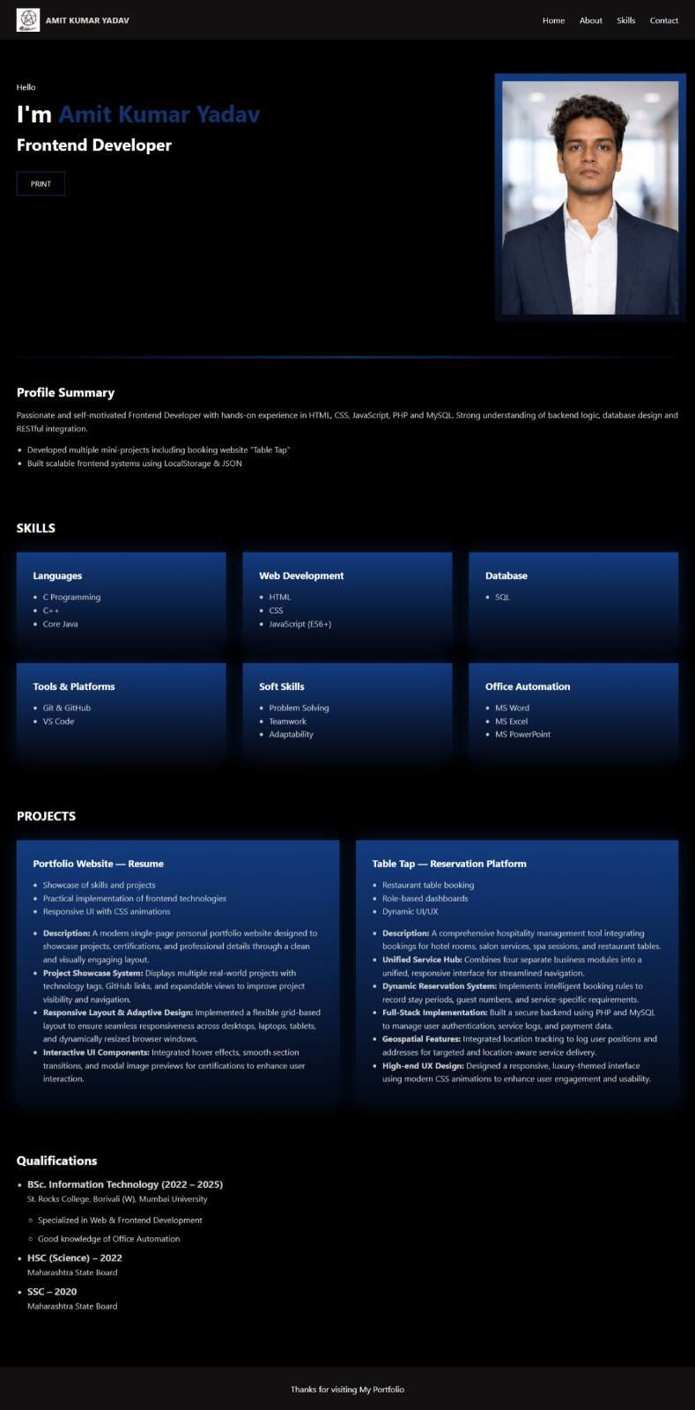

Conclusion
This portfolio serves as a living testament to my dedication to Frontend Development and my ability to bridge the gap between technical logic and user-centric design. By combining a robust skill set in modern web technologies with a clean, responsive aesthetic, I am prepared to contribute effectively to innovative projects in the tech industry.
**************************************************************************
Thanks for visiting My Portfolio!
***************************************************************************

